ADEWALE ADERAYO
53, Post Office Road, Mushin|+2348083848526|talk2derayo@gmail.com
PROFESSIONAL SUMMARY

Strategic and results-driven management professional with over 5 years of experience in operations management, team leadership, human resources coordination, and client relationship management. Proven ability to oversee staff performance, streamline organizational processes and improve operational efficiency. Adept at driving organizational growth through effective people management and structured systems.
CORE COMPETENCIES
•Effective Verbal and Written Communication •Administrative and Office Support •Customer Service & Client Relations •Internet Research •Time Management & Multitasking •Analytical Thinking• Fast Learning and Adaptability
• Team Collaboration
PROFESSIONAL EXPERIENCE
Human Resources Officer | Entourage Integrated Trust Limited (August 2025-Present)
Coordinate recruitment processes including job postings, screening, interviewing, and onboarding. Maintain employee records and ensure compliance with company policies and labor regulations.
Support performance appraisal processes and staff development initiatives.
Handle employee relations matters and assist in conflict resolution.
Develop and implement HR policies and administrative procedures.
Monitor staff attendance, leave management, and payroll support documentation.
Store Manager | Woe Nation (2019 - 2021)
Supervised daily operations and coordinated staff activities to ensure efficiency.
Managed inventory, budgeting, and sales performance.
Improved customer retention through strong service standards.
Implemented operational strategies that increased revenue and productivity.
Studio Artist / Operations Lead | Osan by Misan (2021-2025)
• Coordinated studio schedules, client bookings, and workflow management.
Led collaborative projects with photographers and creatives
Developed client service systems that improved turnaround time and satisfaction
Virtual Assistant (Freelance/Remote) ⁽²⁰²²⁻²⁰²³⁾
•Provided executive administrative support.
•Managed emails, scheduling, documentation, and research tasks.
•Handled customer inquiries and maintained client databases

EDUCATION

BSc. Home & Hotel Management (2019 - 2023)
Olabisi Onabanjo University, Ago-Iwoye
Cosmetology Diploma (2018) Grace Spring
Business & Vocational School

Completed internships with renowned beauty
Lucy Looks Makeup Studio (Makeup)
Classic Oni Diri (Hair)|
Angel Hair Boss (Hair)
Completed 6 months SIWES program at the Neuropsychiatric hospital, aro,
Abeokuta in the nutrition department as well as the kitchen department.

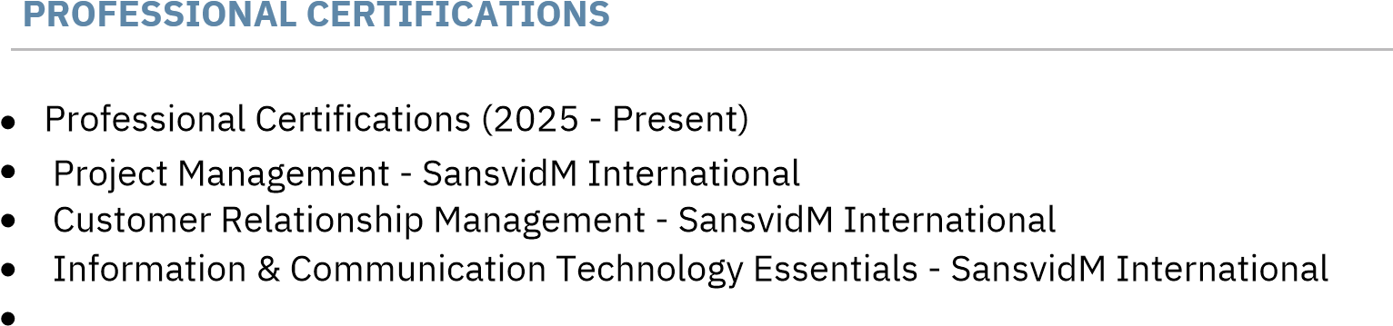

ACHIEVEMENTS

•Represented Ogun State at Beauty of Africa International Pageant (2019)
• Top 9 Finalist - Beauty of Africa International Pageant
HUMAN RESOURCES MANAGEMENT- SansvidM International
HEALTH SAFETY SECURITY AND ENVIRONMENT 182- SansvidM International
HEALTH SAFETY SECURITY AND ENVIRONMENT 3- Sansvid International
Skills Developed:
Poise and stage presence
Public speaking and presentation
Interpersonal relations and networking
Cultural ambassadorship
Tourism awareness and promotion
